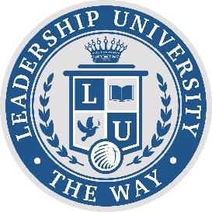

COST PER CLASS $147.00
COST PER TERM $588.00
FINAL COST OF COMPLETION $3528 (6 TERMS)

Member Term Plan 1: Pay In Full- $420 ($168 in savings)
- Member Code Required
- PIF Code Required
- Marriage Code Available (not combinable with scholarships)
- Scholarships Available

Member Term Plan 2: 3 Installments- $504 ($84 in savings)
- Member Code Required
- Marriage Code Available (not combinable with scholarships)
- Scholarships Available

Non-Member Plan 1: Pay In Full- $504 ($84 in savings)
- PIF Code Required
- Marriage Code Available

Non-Member Plan 2: 3 Installments- $588
- Marriage Code Available

Certificate Program- $1000 ($50 a month)
- 20-Month Autopay Sign Up Required
- Certificate Code Required
- Not eligible for marriage code
- Not eligible for scholarships

